1.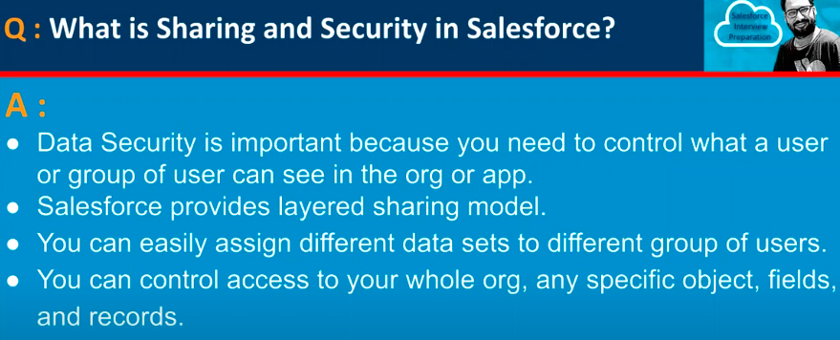

2.

3.

4.

5.

6.

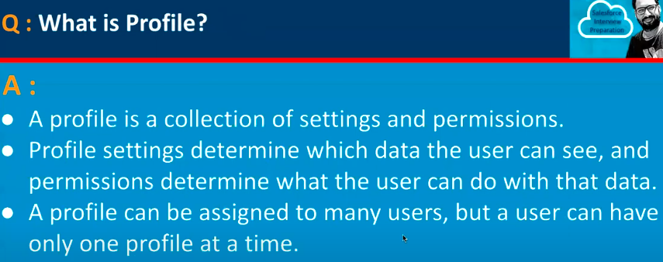

6.

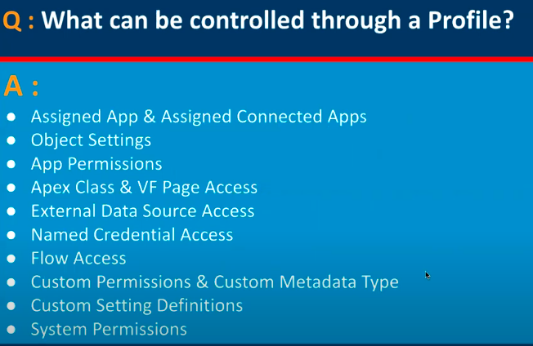

7.

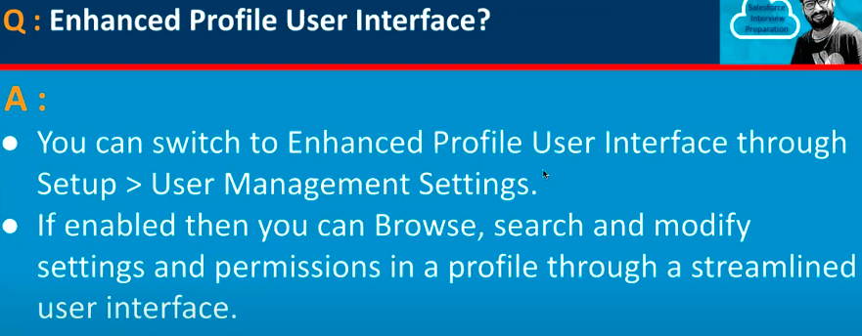

8.

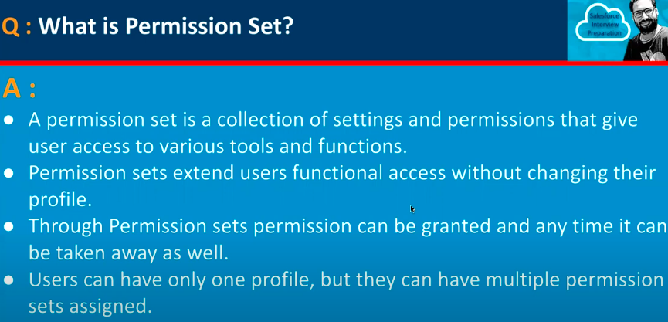

9.

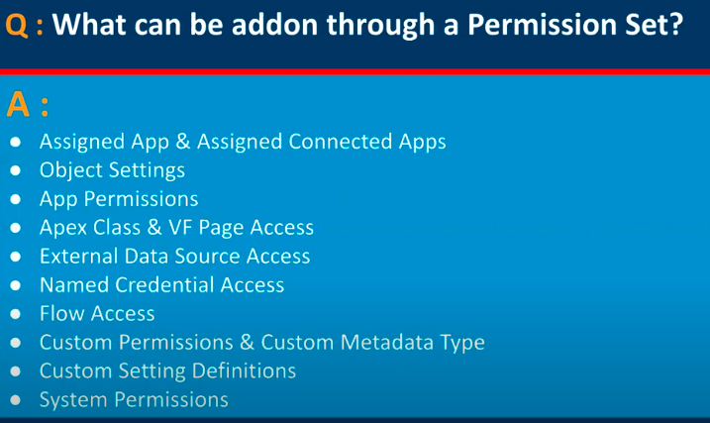

10.

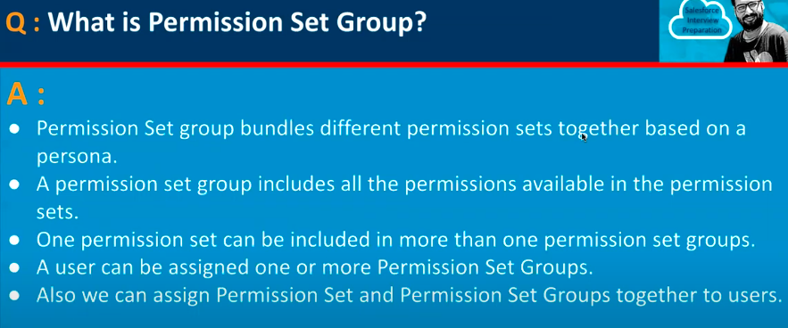

11.

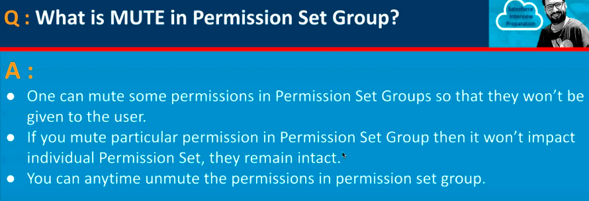

12.

13.

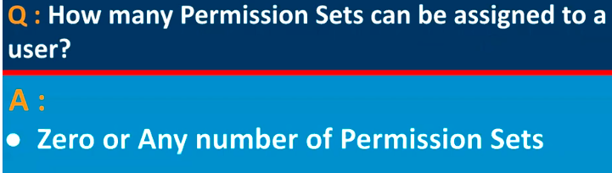

14.

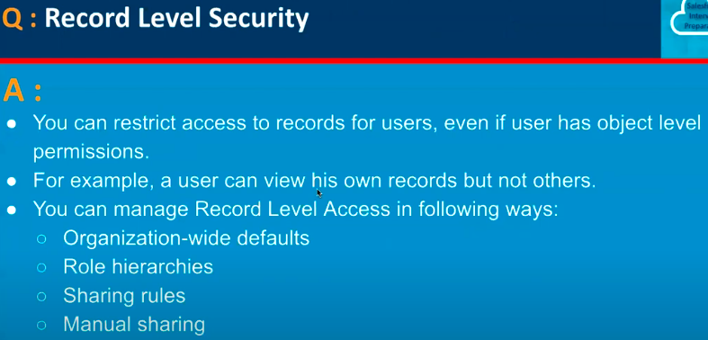

15.

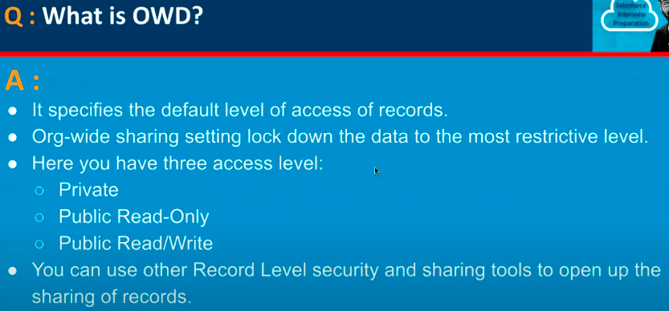

16.

17.

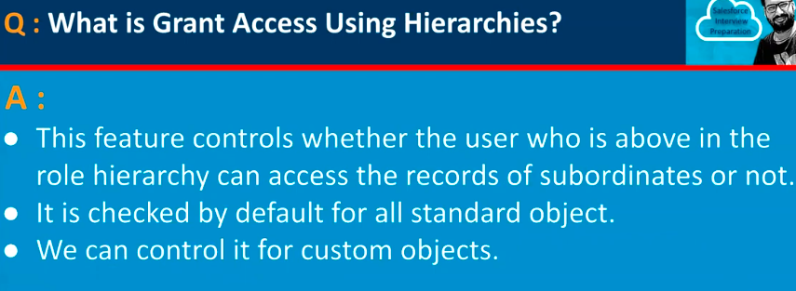

18.

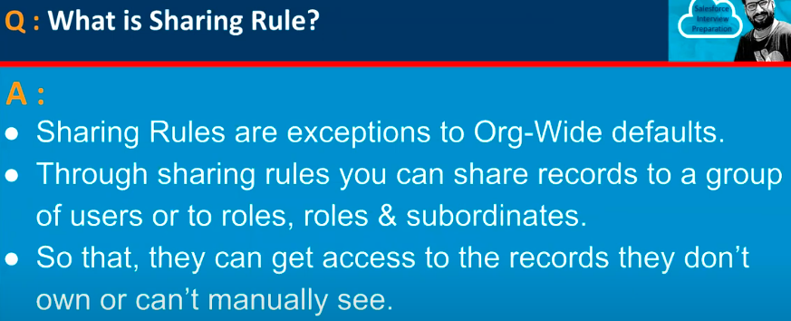

19.

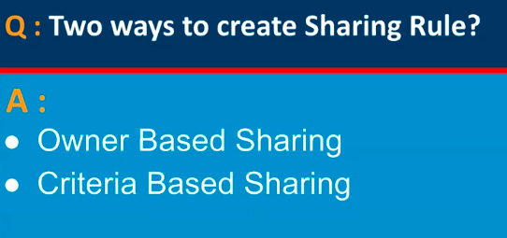

20.

21.

22.

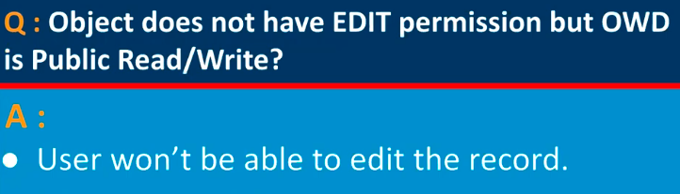

23.

